**Project Title:** Classification of arrhythmia by using deep learning 2-D **Project Design Phase-I** - **Solution Fit Template Team ID:PNT2022TMID30495**

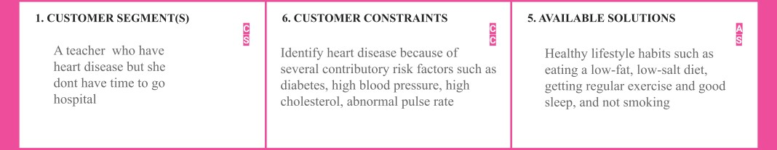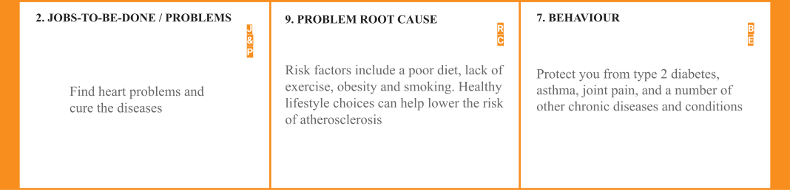

**10. YOUR SOLUTION SL**

**3. TRIGGERS**

Symptoms : Symptoms may include chest pain, nausea, shortness of breath, sweating, dizziness, palpitations.

**TR**

**4. EMOTIONS: BEFORE / AFTER EM**

Before : Especially negative emotions, such as hostility, anger, depression and anxiety, precipitate coronary heart disease

After : Temporary feelings of sadness and a depressed mood are common for the first few weeks.

Vitamin C. Arrhythmias and other heart conditions are associated with oxidant stress and inflammation. Antioxidants like vitamin C and vitamin E appear to be effective in reducing these. You can use vitamin C to treat colds, the flu, and even cancer, and it can also help with arrhythmia.

1. **CHANNELS BEHAVIOR CH**

# ONLINE

**Ex tr ac t on lin e & of ﬂi ne C H**

**of BE**

Customer will Find their heart disease online rather than going hospital

# OFFLINE

Customer will collect their ecg image offline going hospital